**UNIVERSITY MANAGEMENT SYSTEM**

# **PROJECT** INCREASE THE TRANSPARENCY

# AND UTILIZATION OF THE PORTAL

### A PROJECT REPORT

***Submitted by***

**P.S.S.RAMCHAND[192225113]**

**G.KARTHIK REDDY[192211751]**

**G.NAVADEEP REDDY[192211753]**

*Under the guidance of*

## Dr.SENTHIL KUMAR

(Professor, Department of Cyber Security)

***in partial fulfillment for the completion of course CSA0819- PYTHON PROGRAMMING FOR WEB APPLICATIONS***



**SIMATS ENGINEERING**

**THANDALAM**

**MARCH 2024**

## BONAFIDE CERTIFICATE

Certified that this project report titled “**UNIVERSITY MANAGEMENT SYSTEM PROJECT INCREASE THE TRANSPARENCY AND UTILIZATION OF THE PORTAL**” is the bonafide work of “ **P.S.S.RAMCHAND [ 192225113 ] ; G.KARTHIK REDDY [ 192211751 ] ; G.NAVADEEP REDDY[192211753]**” who carried out the project work under my supervision as a batch. Certified further, that to the best of my knowledge the work reported herein does not form any other project report .

Date : Project supervisor: Head of the Department:

**ABSTRACT**

University Management System (UMS) deals with the maintenance of university, college, faculty, student information with in the university. UMS is an automation system, which is used to store the college, faculty, student, courses and information of a college.

Starting from registration of a new student in the college, it maintains all the details regarding the attendance

and marks of the students. The project deals with retrieval of information through an INTRANET based campus wide portal. It collects related information from all the departments of an organization and maintains files,

which are used to generate reports in various forms to measure individual and overall performance of the students.

Development process of the system starts with System analysis. System analysis involves creating a formal

model of the problem to be solved by understanding requirements.

This project work therefore, eliminates or reduces the error of allowing a student to carry out a project that has

been done before as well as cutting down on the cost and time required by the student to produce a quality

technical report. It also helps to prevent the forgery of signatures usually experienced during the final clearance stage of the students after the conclusion of the project work. During the clearance stages, the completed stages

will be noted by the computer until the final stage of the clearance stage is completed and the print button can be clicked upon by the student to bring forth the completed clearance form. In this work, we developed an intranet portal platform that can integrate all the processes above into one system

# TABLE OF CONTENTS

ABSTRACT iii

LIST OF TABLES vii

LIST OF FIGURES ix

ABBREVIATIONS x

1. INTRODUCTION 1
2. METHODOLOGY 5
   1. Hardware Design 5
      1. Raspberry Pi 3 6
      2. Sinumerik CNC 6
      3. I/O Module 6
      4. Relay 7
   2. Software Design 7
      1. Python 3 7
      2. PySimpleGUI 7
      3. Tkinter 8
   3. Parameters 8
      1. Machine Operating Mode: Auto/Manual 8
      2. Part Program Running: Yes/No 8
      3. Cycle Time 8
      4. Part Count 8
      5. Feedrate Override 9
      6. Spindle Running Time 9
      7. Breakdown Hours 9
      8. Machine Running Hours 9
      9. Machine Ready Time 9
      10. Machine Utilization Hours 10
3. IMPLEMENTATION 11
   1. Experimental Setup 11
   2. Program logic for parameters 12
4. RESULTS AND DISCUSSION
   1. Machine Utilization Dashboard 12
   2. GUI Display Screens 13
5. CONCLUSION AND FUTURE 33

ENHANCEMENT

##### A PROGRAM CODES

A.1 Parameters . . . . . . . . . . . . . . . . . . . .

**35**

. . . . . . . . . . .35

* + 1. Machine Operating Mode: Auto/Manual 35
    2. Part Program Running: Yes/No 35
    3. Cycle Time and Part Count 35
    4. Feedrate Override 36

# LIST OF FIGURES

System Flow 5

Design of Cost Effective Module 11

Experimental Setup 1… 11

Experimental Setup 2 11

Machine Operating Mode: Auto/Manual 12

Part Program Running: Yes/No 13

Cycle Time 14

Feedrate Override 15

Machine Running Hours 16

Spindle Running Time 16

Breakdown Hours 17

Machine Utilization Hours 17

Machine Ready 18

Machine Utilization Dashboard Layout 18

Machine Utilization Dashboard 19

Months 19

Weeks in January 20

Weeks in February 20

Weeks in March 21

**INTRODUCTION**

Over the years, portals have become popular in the information system community. A web portal is seen as a special internet (or intranet) site designed to act as a gateway to give access to other sites. A portal aggregates information from multiple sources and makes that information available to various users. It provides a gateway

not just to sites on the web but to all network accessible resources. It offers centralized access to all relevant content and applications [1]. Although there exists so many definitions of the web portal from various perspectives, a common ground to the description of the portal is a single, personalized interface through which users access all information resources in a secure, consistent and customisable manner [2]. Portals connect users not only with everything they need but also with every one they need and provide all the tools they need to work together [4]. Portals were projected to turn the web from institutioncentric repository of information to a dynamic user-centric collection of everything useful to the person in a particular role and this is projection has been realized [3]. Portals have these days become of interest in higher-education institutions. University portals integrate campus-specific information and activities which is stored in the campus electronic vaults such as databases, file systems and existing application systems, with unstructured data (text) from on and off campus [4]. Portal technology is used as a tool to enhance institutional efficiency and productivity. The portal is seen as a system to get ourselves (institutions) organized to better form lifelong impressions [5]. It enables university information system users to communicate with the university information sub-systems securely. Most universities especially in developed countries are either

developing or purchasing portal solutions for their needs.

Been employed in a smaller setting or department, it can be used to automate processes and also enable communication and interaction.

**ANALYSIS MODEL**

The model that is basically being followed is the WATER FALL MODEL, which states that the phases are organized in a linear order. First of all the feasibility study is done. Once that part is over the requirement analysis and project planning begins. The design starts after the requirement analysis is complete and the coding begins after the design is complete. Once the programming is completed, the testing is done. In this model the sequence of activities performed in a software development project are: -

* Requirement Analysis
* Project Planning
* System design
* Detail design
* Coding
* Unit testing
* System integration & testing

Here the linear ordering of these activities is critical. End of the phase and the output of one phase is the input of other phase. The output of each phase is to be consistent with the overall requirement of the system. Some of the qualities of spiral model are also incorporated like after the people concerned with the project review completion of each of the phase the work done.

**S/w and H/w requirements**

1. **Environment:**

* **Servers:** 
  + - * **Operating System Server: -** Microsoft Windows 2000 or Higher
      * **Data Base Server:** Microsoft SQL Server 2000/2005
* **Clients :** Microsoft Internet Explorer,
* **Tools :** Microsoft Visual Studio .Net
* **User Interface:** ASP.NET with AJAX
* **Code Behind :** VC#.NET

1. **Requirements:**

* **Hardware requirements:**

|  |  |
| --- | --- |
| **Number** | **Description** |
| 1 | PC with 2 GB hard-disk  and 256 MB RAM |

* **Software requirements:**

|  |  |
| --- | --- |
| **Number** | **Description** |
| 1 | Windows 2000/ XP/ or Higher with MS-office |
| 2. | MS-SQL server2000/2005 |
| 3. | Ms-Visual Studio .Net 2005 |
| 4. | Ms-Internet Explorer |

**Communicated Requirements**

**Requirements Specification**

**Design Specification**

**Executable Software Modules**

**Integrated Software Product**

**Delivered Software Product**

**Changed Requirements**

**Requirements Engineering**

**Design**

**Programming**

**Integration**

**Delivery**

**Maintenance**

System Requirements Specification:

The software, Site Explorer is designed for management of web sites from a remote location.

**Purpose:** The main purpose for preparing this document is to give a general insight into the analysis and requirements of the existing system or situation and for determining the operating characteristics of the system.

**Scope:** This Document plays a vital role in the development life cycle (SDLC) and it describes the complete requirement of the system. It is meant for use by the developers and will be the basic during testing phase. Any changes made to the requirements in the future will have to go through formal change approval process.

**Developers Responsibilities Overview:**

The developer is responsible for:

* Developing the system, which meets the SRS and solving all the requirements of the system?
* Demonstrating the system and installing the system at client's location after the acceptance testing is successful.
* Submitting the required user manual describing the system interfaces to work on it and also the documents of the system.
* Conducting any user training that might be needed for using the system.

Maintaining the system for a period of one year after installation.

# Modules

A module is a bounded contiguous group of statements having a single name and that can be treated as a unit. In other words, a single block in a pile of blocks.

##### Guidelines for Modularity

* Make sure modules perform a single task, have a single entry point, and have a single exit point.
* Isolate input-output (I-O) routines into a small number of standard modules that can be shared system-wide.
* Isolate system-dependent functions (e.g., getting date or time) in the application to ease possible future conversions to other computer platforms or to accommodate future operating system revisions.

A module is a bounded contiguous group of statements having a single name and that can be treated as a unit. In other words, a single block in a pile of blocks.

**The system after careful analysis has been identified to be presented with the following modules:**

**UMS** (UNIVERSITY MANAGEMENT SYSTEM) makes management to get the most updated information always by avoiding manual accounting process. This system has the following functional divisions.

* University Administrator
* College Administrator
* User (Students / Faculties)
* Reports
* Authentication

**University Administrator** has the functionality of registering new colleges and courses.

**College Administrator** has the rights of creating department, allocating courses to departments, creating faculties, students and allocating subjects to faculties, and modifications in the data entered by the user can also be done by the college administrator.

**User** of this may be faculty or students. Faculty has the facility of entering the marks and attendance of the students. Students can check their marks and attendance but there is no chance of modifications.

**Reports** must be generated for the existing data i.e. for attendance and marks of the students, which are used to assess the performance of the students. These reports should be viewed by the in charge and user.

**Authentication:** this module contains all the information about the authenticated user

. User without his username and password can’t enter into the login if he is only the

authenticated user then he can enter to his login.

## Architecture

Visual overview of the Common Language Infrastructure (CLI)

Common Language Infrastructure

The core aspects of the .NET framework lie within the Common Language Infrastructure, or CLI. The purpose of the CLI is to provide a language-neutral platform for application development and execution, including functions for exception handling, garbage collection, security, and interoperability. Microsoft's implementation of the CLI is called the Common Language Runtime or CLR.

[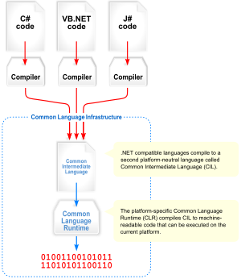](http://en.wikipedia.org/wiki/Image:Overview_of_the_Common_Language_Infrastructure.svg" \o "Visual overview of the Common Language Infrastructure (CLI))

**SECURITY IN SOFTWARE**

System security refers to various validations on data in form of checks and controls to avoid the system from failing. It is always important to ensure that only valid data is entered and only valid operations are performed on the system. The system employees two types of checks and controls:

CLIENT SIDE VALIDATION

Various client side validations are used to ensure on the client side that only valid data is entered. Client side validation saves server time and load to handle invalid data. Some checks imposed are:

* VBScript in used to ensure those required fields are filled with suitable data only. Maximum lengths of the fields of the forms are appropriately defined.
* Forms cannot be submitted without filling up the mandatory data so that manual mistakes of submitting empty fields that are mandatory can be sorted out at the client side to save the server time and load.
* Tab-indexes are set according to the need and taking into account the ease of user while working with the system.

**SERVER SIDE VALIDATION**

Some checks cannot be applied at client side. Server side checks are necessary to save the system from failing and intimating the user that some invalid operation has been performed or the performed operation is restricted. Some of the server side checks imposed is:

* Server side constraint has been imposed to check for the validity of primary key and foreign key. A primary key value cannot be duplicated. Any attempt to duplicate the primary value results into a message intimating the user about those values through the forms using foreign key can be updated only of the existing foreign key values.
* User is intimating through appropriate messages about the successful operations or exceptions occurring at server side.
* Various Access Control Mechanisms have been built so that one user may not agitate upon another. Access permissions to various types of users are controlled according to the organizational structure.
* Only permitted users can log on to the system and can have access according to their category. User- name, passwords and permissions are controlled o the server side.
* Using server side validation, constraints on several restricted operations are imposed.

**MAINTANACE**

Maintenance the last phase in the software engineering process. As programs are developed.

A distributing trend has emerged the amount of effort and a resource expended

on software maintenance is growing. In total project development maintenances

takes 65% of effort .In software maintenance there are four .They are

* Adaptive Maintenance
* Corrective Maintenance
* Perfective Maintenance
* Preventive Maintenance

Adaptive Maintence is applied when changes in the external environment

precipitate modifications to software. I deals with adapting the software to new

environments.

Perfective Maintence incorporates enhancements that are requested by user community. It deals with updating the software according to changes in user requirements

Corrective Maintence acts to correct errors that are uncovered after the software is in use . It deals with fixing bugs in the code

Preventive Maintence improves future maintainability and reliability and provides a basis for future enhancement.It deals with updating documentation and making the software more maintainable .Tasks performed during the software engineering process define maintainability and have an important impact in the success of any maintenance approach .Reverse Engnieering and Reengineering are the tools and techniques used to maintain the project.

There are four major problems that can slow down the maintence process

* Unstructured code
* Maintence programmers having insufficient knowledge of the System
* Documentation being absent
* Out of Date , or at best insufficient

The success of the maintence phase relies on these problems being earlier in the life cycle

**Methodology:**

The methodology for a University Management System project involves a systematic approach to designing, developing, and implementing the system. Some key aspects of the methodology include:

* Defining the scope and objectives of the project.
* Identifying the target audience and their needs.
* Conducting a thorough analysis of the current system and identifying areas for improvement.
* Developing a detailed plan for the implementation of the new system.
* Testing and evaluating the system.
* Ensuring the system is user-friendly and meets the needs of the target audience.

**Methods of Data Collection:**

Efficient data collection methods are essential for gathering accurate information to support the project. Some common methods include:

* Surveys and questionnaires to gather feedback from students, faculty, and staff.
* Interviews and focus groups to gather insights from key stakeholders.
* Observation and analysis of existing systems and processes to identify areas for improvement.
* Data mining and analysis of existing data sets to identify trends and patterns.

**MAPPING OF MANAGEMENT PORTAL**

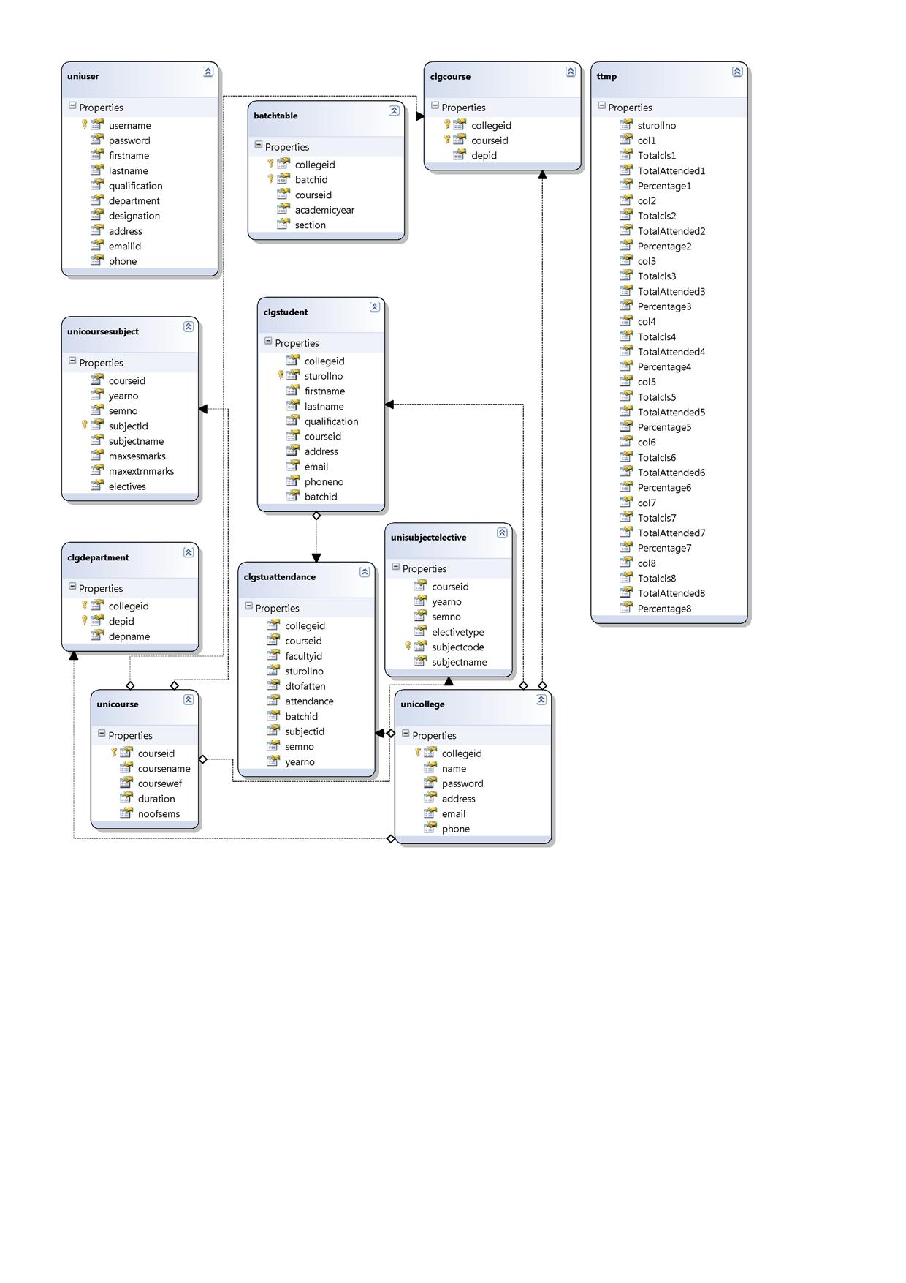

##### **Activity Diagram for college administrator and hod:**



**University admin login**

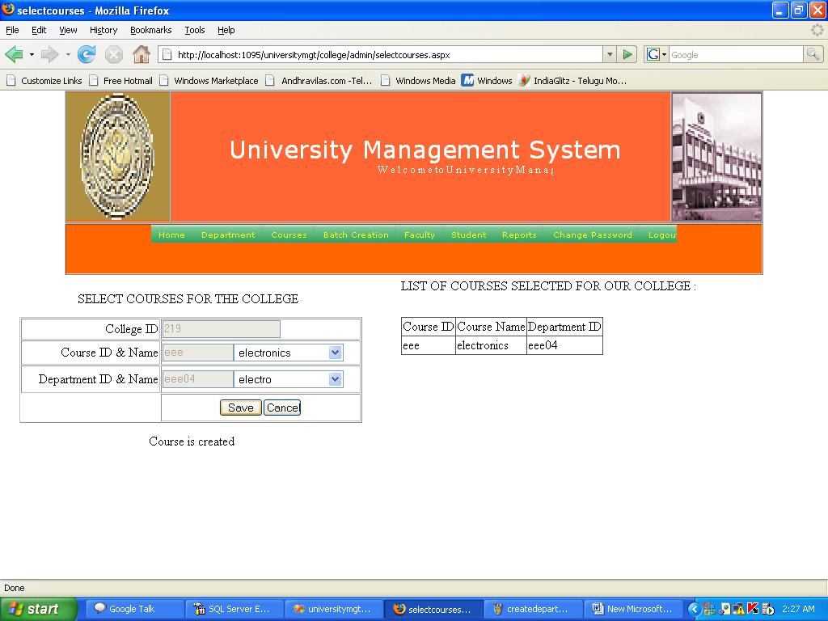

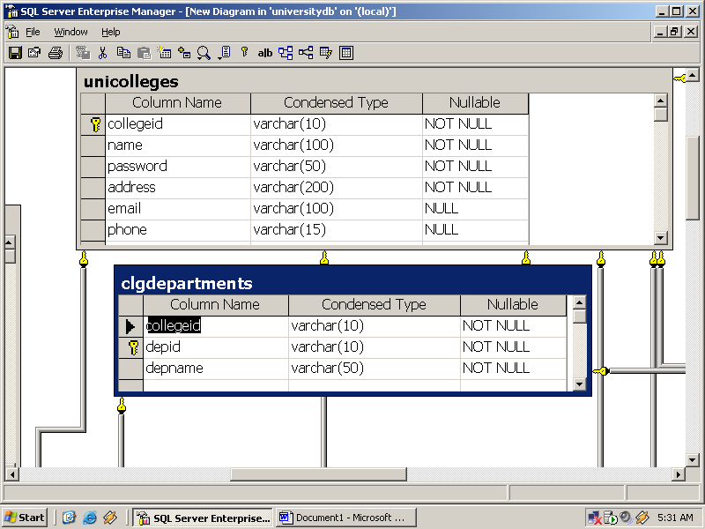

**Student Login:**

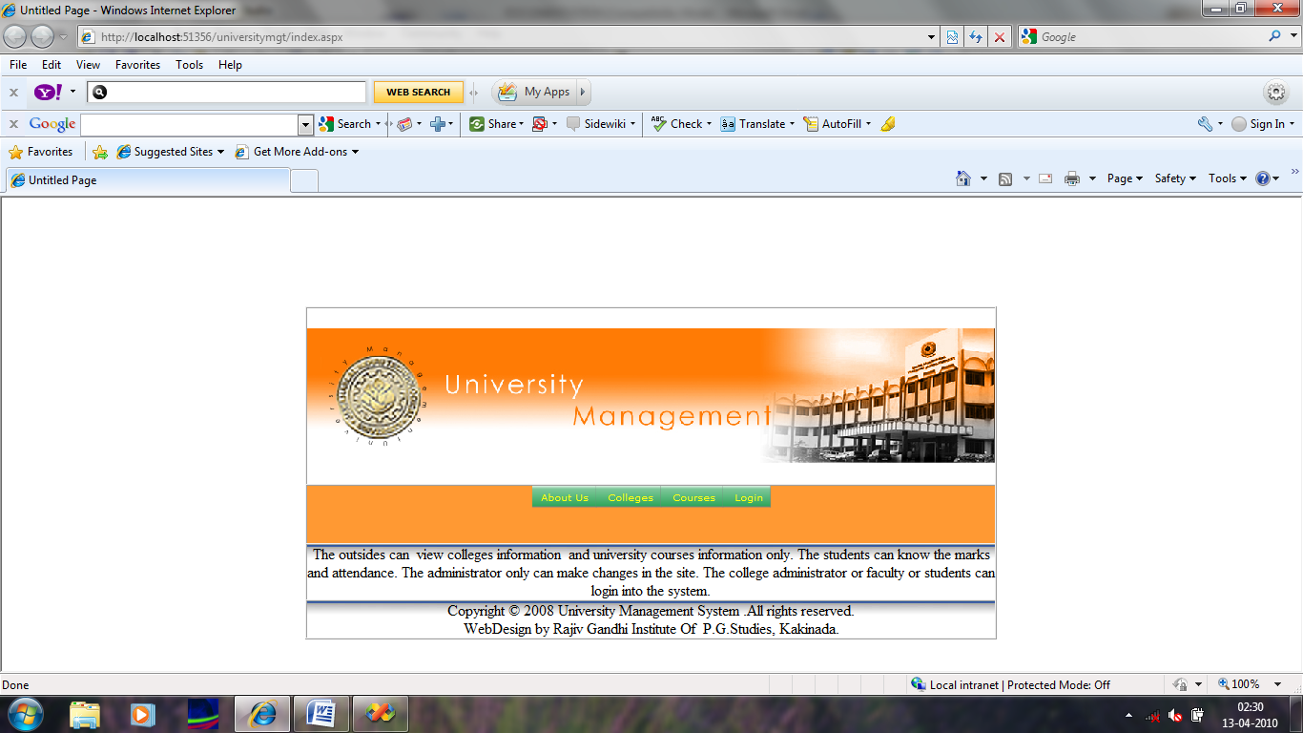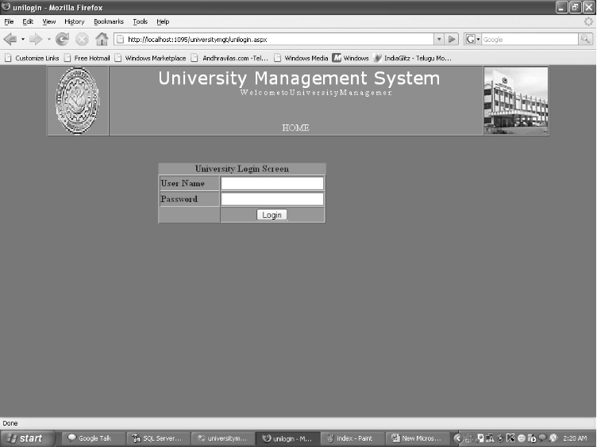

.

**Result and Discussion:**

When presenting results in the project report, it is vital to discuss findings thoroughly. This may involve:

1. Analyzing the impact of the University Management System on student performance.
2. Evaluating the efficiency of the system in managing academic records.
3. Discussing any challenges faced during implementation and how they were addressed.
4. Providing recommendations for future improvements and updates to the system.
5. By incorporating a well-defined methodology, appropriate data collection methods, and insightful result discussions, a comprehensive University Management System project report can be developed effectively.

**Implementation:**

The overall goal of the work is to develop a flexible index framework that can be tuned to achieve effective static index selection and online index selection , the goal is to develop a system that can be recommended an evolving set of indexes for incoming queries overtime such that the benefit of index set changes out weight the cost of making those changes. These differentiate between low-cost index set changes and higher cost index set changes.

The benefit of using a potential index over a set of queries, it is necessary to estimate the cost of executing the queries with and without index. The cost model is embedded in to the queries should be answered using a sequential scan or using an existing index. Instead of using the query optimizer to estimate the query cost.

This implementation technique differs from existing tools in determine potential set of indexes to evaluate and quantization basic technique that estimate every costs. All the common goal indexes work in design time. The DBA decide when to run the wizard and over with which workload.

**Basic Design Approch**

The goal of the design phase is to transform the requirements specified in the SRS document into a structure that is suitable for the implementation in some programming language. Design involves preparing a detailed analysis of different functions to be supported by the system and identification of data flow among different functions.

Stages of system design are:

1.Conceptual Design

2.DataBase Design

3.Functional Design

CONCLUSION

It has been a great pleasure for me to work on this exciting and challenging project. This project proved good for me as it provided practical knowledge of not only programming in ASP.NET and C#.Net web based application and no some extent Windows Application and SQL Server, but also about all handling procedure related with “University Management system”. It also provides knowledge about the latest technology used in developing web enabled application and client server technology that will be great demand in future. This will provide better opportunities and guidance in future in developing projects independently.

BENEFITS:

The project is identified by the merits of the system offered to the user. The merits of this project are as follows: -

* It’s a web-enabled project.
* This project offers user to enter the data through simple and interactive forms. This is very helpful for the client to enter the desired information through so much simplicity.
* The user is mainly more concerned about the validity of the data, whatever he is entering. There are checks on every stages of any new creation, data entry or updation so that the user cannot enter the invalid data, which can create problems at later date.
* Sometimes the user finds in the later stages of using project that he needs to update some of the information that he entered earlier. There are options for him by which he can update the records. Moreover there is restriction for his that he cannot change the primary data field. This keeps the validity of the data to longer extent.
* User is provided the option of monitoring the records he entered earlier. He can see the desired records with the variety of options provided by him.
* From every part of the project the user is provided with the links through framing so that he can go from one option of the project to other as per the requirement. This is bound to be simple and very friendly as per the user is concerned. That is, we can sat that the project is user friendly which is one of the primary concerns of any good project.
* Data storage and retrieval will become faster and easier to maintain because data is stored in a systematic manner and in a single database.
* Decision making process would be greatly enhanced because of faster processing of information since data collection from information available on computer takes much less time then manual system.
* Allocating of sample results becomes much faster because at a time the user can see the records of last years.
* Easier and faster data transfer through latest technology associated with the computer and communication.
* Through these features it will increase the efficiency, accuracy and transparency

**LIMITATIONS:**

* The size of the database increases day-by-day, increasing the load on the database back up and data maintenance activity.
* Training for simple computer operations is necessary for the users working on the system.

**FUTURE ENHANCEMENTS**

* It can be implemented to upload files with an huge amount of size with the support of various file formats.
* This System being web-based and an undertaking of Cyber Security Division, needs to be thoroughly tested to find out any security gaps.
* A console for the data centre may be made available to allow the personnel to monitor on the sites which were cleared for hosting during a particular period.
* Moreover, it is just a beginning; further the system may be utilized in various other types of auditing operation viz. Network auditing or similar process/workflow based applications...

**REFERENCES**

1. Web Portals: The new gateways to internet information and services by

Arthur Tatnall (Victoria University, Australia).

[2] Educational portals: A way to get an integrated, user –centric university information system by Marko Bajec (University of Ljubljana, Slovenia).

[3] All about web portals; a homepage doth not a portal make by Howard Strauss.

[4] Boston College university-wide information portal: concepts and recommended course of action; Gleason, B.W (2000).

[5] Web portals and higher education; technologies to make it personal:

Richard N Katz.

[6] The new international Webster’s comprehensive dictionary of English Language.

[7] BBC English Dictionary.

[8] Educational Portal Strategy; Alf Newman (University of Cologne, Germany), Henrik Hank e (University of Duisburg-Essen, Germany).